To complete this document, replace the variable (blue) information with the correct information for your project, then change the font color to ‘auto’.

Project Name: Enterprise Scheduling & Workflow

Concept Proposal

7/8/2003

Version: 1.0

Author: Jeff Wallk
Champion Mark Parise
Program / Initiative:
Enterprise Process Management

Project Type: (Check the box that represents this project) | Yes | No
Revenue Generating
Cost Reduction | X
Quality Improvement | X
Marketplace Parity
Technology Enhancing | X
Other ()

NPD Process History

Toll Gate # | Outcome | Date | Remarks
Toll Gate | Approval Outcome | Date | Brief description of outcome

Revision History
Accept Date | Revision # | Author | Remarks
Ver. Date | Version | Author | Brief description of changes made

Section 1.0: Project Nomination (Toll Gate # 1)

Enter information in Section 1 and submit this form with the Project Nomination form to the Quality Council. This information will be used by the Quality Council to determine whether or not this project should proceed to the Project Scoping Stage.

1.1 Statement of Need/Concept
Describe fully the business/economic conditions that warrant the new product / improvement.
The goal is to identify a 3rd party tool (or suite of tools) that provide integrated scheduling and workflow services to provide centralized control and management of all technical and business activity. Once the tool is in place, smaller initiatives can be implemented to migrate existing applications to use the scheduling tool. At the same time, the business areas can begin automating manual processes to streamline operations and provide improved control.
Define the opportunity (+ target markets) / benefits (+target processes) that make this an attractive pursuit.
Most of these benefits fall under risk mitigation with some impact on cost consolidation:

- Decommission SUN boxes- no longer supported by vendor.
- Decommission Solaris 2.4 & Oracle 7.3 instance on the SUN boxes- no longer supported by vendor.
- Eliminate the processing for MONET and support for the associated scripts
- Eliminate the significant security exposure to IRI of allowing a 3rd party direct access into our production environment and network.
- Eliminate non-standard ITO maintenance and backup procedures.
- Positions MIF along side other Suppliers using SLAs and best practices to manage the relationship.
- The proposed solution is supported by IRI’s existing disaster recovery plans.

Please note: If the current processing environment housed on the outdated SUN boxes fails, IRI will not be able to load causal data into our systems until it’s fully restored. Given the environment is supported by non-standard processes this will take much longer to achieve.

Note: The C-Store project is going to require an immediate move the approval & receipt of audit data from Tuesday noon to Monday. MIF will only commit to this process change after IRI commits to timelines for this transition.

1.3 Sample Financials

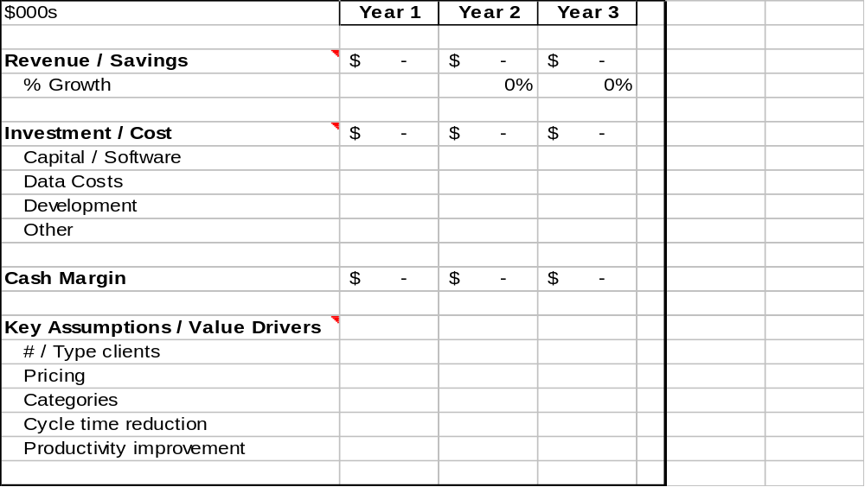

End of Section 1.0. Once the Quality Council approves the project, continue on to section 2.0.

Section 2.0: Project Benefit Analysis (Toll Gate # 2)

Completion of this form is the responsibility of the Process Owner or their designee. The Project Scoping Facilitator will provide guidance and assistance
- Automation of the current “launch process” alone will achieve upwards of $2-3 MM in savings annually.
- Automation of Retailer & European submissions will greatly reduce headcount and improve quality of deliverables.
- Elimination of redundant scheduling systems will reduce headcount and costly overhead associated with maintenance for those systems.
- Centralized capture of key performance data across multiple platforms for all services and activities.
- Centralized control and management of resources (both human and capital).
- Component-based approach to create building blocks of workflow to facilitate automation of key business processes.
- Provides the business with a scalable solution to migrate from a technology orientation towards a business solution orientation.
- Automatic contingencies for business and technology activities can be implemented into a cohesive framework (should not appear disjointed and asynchronous to business managers)

Enter information for sections 2.1, 2.2, and 2.3 and send to Emily Higgins (Project Scoping Facilitator). In this phase, the facilitator and will assist you with gathering additional information that will be presented to the Quality Council. A financial analyst will be assigned to assist you with section 2.6. The Quality Council will determine whether or not this project should be prioritized on the platinum list and assigned management and development resources.

2.1 Objective/Scope Statement
Give a short paragraph stating the goal and vision of the project. This should include the desired business outcome.
For commercial projects, give a short paragraph describing the proposed service offering or product enhancement and the business problem it solves:
- Business issue being addressed
- How need is currently met
- How IRI proposed solution meets
Objectives

- Eliminate redundant scheduling systems and applications (JST, LSF, MAESTRO to name a few)
- Deploy resources used to maintain existing scheduling systems to more productive activities.
- Migrate all applications to the ESW (multi-year effort).
- Integrate key Business Operations into the ESW to reduce manual overhead (esp. in DBS)
    - Retailer Submissions
    - European Submissions for manufacturers
    - US Submissions for manufacturers
- Capture key performance metrics for optimization of capacity (both human and capital).
- Integrate SLA metrics into the ESW to provide automated triggers for notification/escalation.
- Incorporate the Order Management process model into the ESW (where Work Orders drive Order Entry & Submission directly)

Scope (In):
- Evaluation and acquisition of a 3rd Party ESW tool (or suite of tools)
- Purchase of additional hardware (TBD) to support the ESW
- Automation of US Retailer & Manufacturer Submissions
- Automation of European Retailer & Manufacturer Submissions
- Replacement and Retirement of existing scheduling systems in the Unix and NT platforms.
- Development of Workflow “components” that provide reusable building blocks for rapid deployment of Business Process Automation.
- Development of reports Key Performance Indicators (KPIs) for managing throughput and monitoring capacity and productivity.

Scope (Out):
- Mainframe topology may be out of scope depending on whether we can leverage existing job scheduling from mainframe and integrate with the 3rd party ESW. (purely from a cost avoidance approach).

2.2 Voice of the Customer
Briefly describe the target market for this offering, the primary end user group(s) within the Client, the business value gained, and estimate of revenue opportunity for IRI. Include assumptions and sources for assumption for the following:
- Target Market / End user segment type
- Total Market Potential
- Likely Early Adopters / #s
- Adoption rates
- Pricing Assumptions
- Revenue projections
- Competitive and Substitutable offerings
- Critical product differentiators

2.3 General Requirements:

2.3.1 General Requirements, Functions and/or Enhancements:
List the general requirements of the project. This should be complete enough to allow groups to understand whether they will be affected. This includes applications/tools that may be affected; identify space needs (production and test needs)

2.3.2 Proposed Approach (Technical, Operational, etc.):
Give a brief statement about the suggested approach, including what existing infrastructure components might be used and other alternative approaches that could be considered. This should include the justifications relative to the solution value proposition.

- Planned use of IRI existing infrastructure components (ex: file space on UPCSelect, web server for hosted application, etc):
- Use of existing software modules or tools (ex: QS3 for extraction, RGT, OSA)
- Originating Data Source(s) being accessed (existing/newly created InfoViews, UPCSelect)
  - Internal
  - External
- Data Source driving the planned application (new RDBMS, access DB, MSAS)
  - Internal
  - External
- Known or potential new software/hardware needed (please tie to product function and/or value proposition)

A 4-phased approach is recommended to purchase and implement process automation software:

Phase 1: RFP for ESW Tool
- RFP developed by AD, ITO & DBS
- Proposals from leading vendors
- Vendor Selection & Business Justification

Phase 2: Implementation Plan to establish footprint
- Capital Spending Approval(s) for Hardware
- Capital Expense Approval for Software & licenses
- Detailed implementation plan.

Phase 3: Pilot Study - Scheduling
- Identify Pilot application
- Create project plan and execute.
- Evaluate success and provide mgmt. Report on lessons learned.
- Establish Best Practices

Phase 4: Rollout
- Identify applications and/or systems to migrate to ESW.
- Identify business processes to migrate to ESW.
- Prioritize systems, applications and business processes to migrate.
- Publish multi-phased plan
- Publish ROI with each plan.

Ongoing (Prioritize Projects and secure funding):
- Run projects through PI Committee.
- Review list of priorities with executive management.
- Secure funding for each project and assemble project team.

2.4 Known Dependencies and Risks:

2.4.1 Dependencies:

- Identify other projects that could impact or be impacted by this project.
- Window of time for Market Opportunity
- Known reliance on existing IRI or IRI partner offering
- State any projects that you know of that have to be done before this project can be started/completed.
- State other current or proposed projects that cannot be done unless this project is completed.
- State any projects that could not / should not be done if this project is done, due to resource competition or logical incompatibility.
Assumptions
- Acceptance from both business and technology leaders that ESW is a core capability for the organization to be successful.
- We will be able to “phase-in” an ESW tool into our existing topology with no impact to existing systems and schedulers.
- There are no significant technical hurdles on any platform.
- A sufficiently robust tool (or suite of tools) is available [and in use] in the marketplace.
- The architecture team supports the use of an ESW as the core infrastructure from which to rebuild the Supply Chain.
- The business managers are ready to embrace process automation.
- The implementation of an ESW will not impact client deliverables and their expected timelines.
- The implementation of an ESW will not impact progress for New Horizons.
- The ESW will be able to run across all IRI platforms.
- The ESW will be able to provide a global solution (won’t leave Europe out).
- The ESW will incorporate latest technology to facilitate communication at a process and human level (XML, MAPI, Telephony..where appropriate)

Architecture Impact:
- Will directly impact any future application designs
- Will directly impact future business operations and their integration with creation/delivery of client data.
- Will directly impact the business/technical approach for implementing Order Management throughout the organization.
- Will likely impact MIF Transition (in a positive manner)

Architecture Dependencies:
- Should not be any dependencies on New Horizons. The ESW should be independent of the current priorities (as we know them).
- Depending on the direction and timing for New Horizons projects, there may be some upfront planning that is required (or recommended) to decide how best to leverage the ESW as part of new design or to provide future capability.
2.4.2 Risks:

What are the barriers to reaching the goals of the project? Do these risks require we take immediate action? These risks should be evaluated in terms of probability and impact (what is the probability of the risk occurring vs. the impact the risk would have on reaching the project goals).
- New IRI skill sets needed (Technical / Client service training / Support / etc.)
- Legal constraints or contractual barriers
- Market adoption uncertainties
- Partner dependencies with potential impact

Risks

2.5 Resource Requirements, Conflicts, and High Level Schedule:

2.5.1 Development and Project Resource Requirements
List the groups that would need to be involved in the project.

List the groups that would need to be involved in the ongoing operation.

This estimate will show the number of hours required by functional area and band and the cost associated with these hours.

2.5.2 IT Resource Requirements

- Purchasing (contract negotiations, pricing, licensing)
- ITO Resources (implementation, support)
- AD Resources (training, development, Implementation)
- Architecture Team (review, planning, best practices)
- QA (testing)
- DBS (planning, requirements, SOPs, testing)
- Europe (planning, requirements, SOPs, testing)
- Commercial Software (planning, development)

2.5.3 Resource Conflicts with Platinum list projects

2.5.4 High Level Work Plan

2.6 Refined Revenue/Savings and Cost Estimates

A financial analyst will be assigned to the project to work with the key contact and facilitator in developing the profit model.

Profit Model Template
Product Name:
Product Manager:
Financial Analyst:
Revenue
Total Revenue
Less: Discount
Direct Expenses
Data Acquisition
Data Payments/Amrt
Causal
Audit
Other
Data Manipulation (tt)
Dictionary
Projections
Data Loading
Technology & Development
Development
Processing
Storage
Technology Support
Depreciation (Capex)
Depreciation (Internal SW)
Capitalization
Amortization
Marketing
Compensation
Promotions/Advertising
Other
Travel
CSC Operational Support
Indirect Expenses
Sales & Servicing
CS (incl KEG)
TCS
AIG
Delivery/Service Bureau
RCS
Support
Overhead/G&A Expense (15% of cost)
Operating Profit/(Loss)
Capital Expenditures
Data Payments

(see Appendix A for details)

End of Section 2 Outcome will be summarized in Section 3.

Section 3.0: Outcome Summary: Project Scoping (Toll Gate # 2)
To be filled in by Project Benefit Analysis Facilitator.
- Summary of Quality Council Decision
- Project Priority (if applicable)
- Impact on current Platinum List projects (if applicable)
  - Did another project’s priority change?
  - Communication plan to project stakeholders
  - Schedule changes to other platinum list projects
- Project Manager Assignment (if applicable)
- Anticipated Start Date and Next Steps (if applicable)

Appendix A: Cost Breakdown per PI Estimates

Group |  | Development Cost | Annual Cost
Technology Total |  | $49,340 | $13,804
IBS |  | $45,276 | $13,708
IBS QA |  | $0 | $0
ITO |  | $1,440 | $96
Comm SW |  | $0 | $0
Comm SW QA |  | $0 | $0
Architecture |  | $2,624 | $0
DSD Management |  | $0 | $0
DBS Total |  | $0 | $0
S&P |  | $0 | $0
RIS |  | $0 | $0
Delivery |  | $0 | $0
DBS All Other |  | $0 | $0
All Other |  | $17,573 | $5,077
Total |  | $66,913 | $18,880

